8. Work and Energy Part 2

7. Work and Energy Part 1

12. Rotation and Moment of Inertia Part 2

11. Rotation and Moment of Inertia Part 1

10. Momentum and Collisions Part 2

9. Momentum and Collisions Part 1

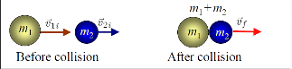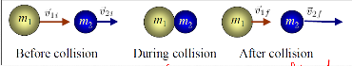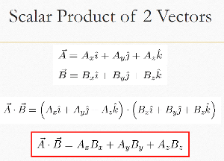

Time present = use at

Else use ar (if ask for centipedal, use ar)

Arc length

Radial acceleration

tangent acceleration

**I =½**MR^2

Moment of Inertia for different objects

Moment of Inertia

Angular Motion (Rotational motion of body)

Kinematics (Angular vs Linear)

θ – θ0 = 1/2(ω0 + ω) t

θ => can be use to find m and angle/rad

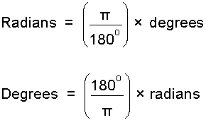

Centre of Mass (Shaped object)

Centre of Mass (System of particles)

Centre of Mass (Extended Object)

Characteristics of CM

Centre of mass (Right angle triangle)

Centre of mass (Cone)

Motion of system of particles

Momentum and Collision

P = mv (Momentum)

P = KE =

**Remember where all forces and momentum are present.**

Elastic Collision

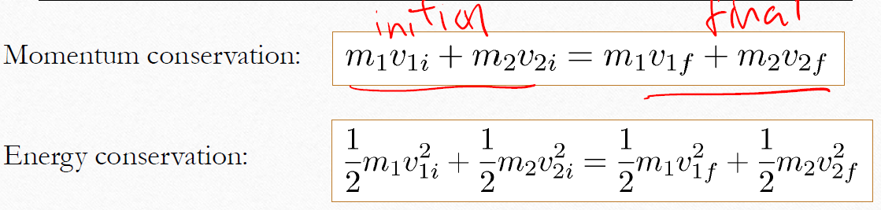

Final Velocity

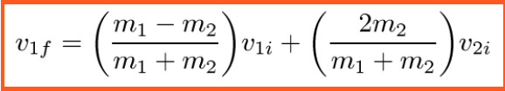 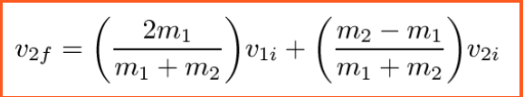

Inelastic Collision

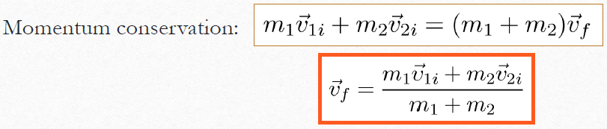

Inelastic Collision

**Momentum found at collision.**

Properties of conservative force

Force is independent of path.

Force at end = Force at start

Power

P = mv(Momentum)

Pav = W/t

SI unit : Watt(W)

1 horsepower = 746W

1 kWh = 103 x 3600 Ws = 3.6 MJ

Reminder

F = μmg = ma = mg

J = F x T

Work Done

**W = F . S(Constant)**

**W = KE = ½mv^2(Kinetic)**

**W = GPE = mg**

**h (Gravitational)**

**W = SE = ½kx^2(Spring)**

**W = KE = ½mv^2­­f – ½v^2i**

**W = KEf + GPEf = KEi + GPEi**

**(Same idea for GPE & SE when displacement occur)**

**Momentum from start and end is the same(conserved)** 

**Mechanical energy (ME) = KE = GPE = SE**

